

Volunteer Role Description
About Doncaster Mind:
Doncaster Mind is a passionate and energetic organisation that works to promote recovery from mental ill-health, improved emotional well-being and independent living.
We offer a range of both face-to-face and online services from one-to-one support, groups, activities, guided learning, training and volunteering opportunities.
Our team really care about making a difference to the people of Doncaster and we work hard to make a positive change for people’s mental health. We have been supporting people in Doncaster and the surrounding area for over 47 years.
Our services range from mentoring, counselling as well as group support – guided learning, peer support and wellbeing groups.

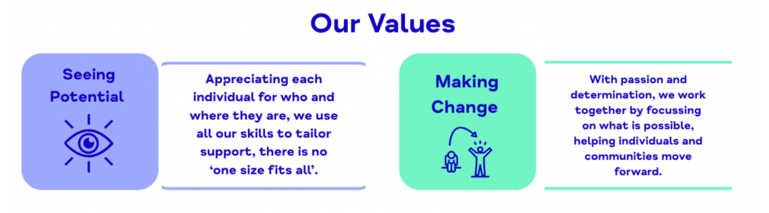
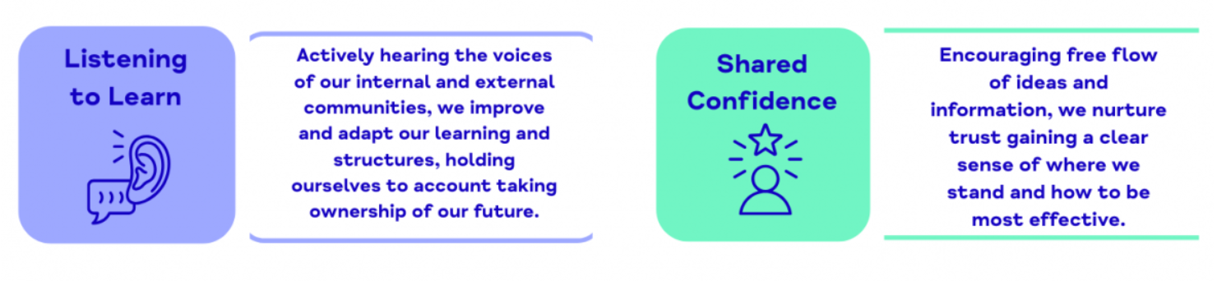

The Aim of the Role:
The aim of this role is to play a key part in the successful day-to-day operation of the office by providing high-quality reception, administration, and customer service support. The role serves as the welcoming face of the organisation, building positive relationships with clients and visitors while ensuring all administrative processes run smoothly and efficiently.

Role Title: Volunteer Receptionist.
Commitment:
Minimum of 3.5 hours per week – hours and days are negotiable.
Tasks:
Our volunteers will help create a welcoming, organised and professional experience for clients and external partners while contributing to the wider work of Doncaster Mind. Key duties include:
Service support:
- Welcoming clients, visitors and partner organisations.
- Creating a friendly and inclusive environment.
- Monitoring and responding to the office inbox.
- Answering telephone calls and booking consultations.
- Ensuring reception is tidy and welcoming.
- Responding to enquiries via telephone, written or email.
- Managing access to the building.
- Other administrative duties as required.
Client experience
- Helping maintain a calm and welcoming environment
- Supporting reception and visitor experience where appropriate
- Preparing small client experience materials/resources
General
- Working in line with Doncaster Mind values
- Maintaining confidentiality
- Participating in supervision and training
- Supporting the wider aims of Rise and Doncaster Mind

Essential skills:
- Good communication and interpersonal skills.
- Experience using Outlook email and calendar.

- Experience of working in a busy environment.
- Friendly, approachable and professional manners.
- Ability to work respectfully with a wide range of people and communities.
- Organised and reliable approach to tasks.
- Comfortable using email, Microsoft Office and basic digital platforms.
- Ability to maintain confidentiality and professional boundaries.
- Ability to work independently as well as part of a team.
- Interest in mental health, wellbeing and community support.
- Willingness to learn and take guidance from staff.
- Understanding of the importance of equality, inclusion and non-judgmental practice.

Desirable skills:
- Experience of volunteering, customer service and administration.
- Experience engaging with members of the public face-to-face.
- Awareness of mental health or wellbeing issues.
- Interested in therapy, psychology, counselling or community development.

Practical Skills:
- Good written and verbal communication skills, with attention to detail.
- Ability to manage time and prioritise tasks appropriately.
- Ability to use initiative appropriately.
- Confidence supporting both digital and in-person activities.
- Ability to adapt to changing priorities within a developing service.
Training:
As part of the Doncaster Mind team, volunteers will receive an introduction and induction to the organisation, including an overview of our services, values and approach to mental health support.
Volunteers will receive:
- A structured induction into the role and service.
- Ongoing support from the Volunteer Co-Ordinator and wider team.
- Regular check-ins and opportunities to discuss development and learning.
- Guidance around professional boundaries, confidentiality and safeguarding.
- Opportunities to shadow and learn from experienced staff where appropriate.
- Access to relevant internal training linked to the role.
Depending on the role and areas of interest, our volunteers may also have opportunities to develop knowledge and skills in:
- Mental health awareness.
- Community engagement and promotion.
- Social media and digital communication.
- Service administration and co-ordination.
- Working within a professional mental health setting.
Boundaries of the role:
To work within the organisation’s confidentiality policy and volunteer agreement.
The Difference You Will Make
By volunteering as a receptionist, you will help create a positive first impression of Doncaster Mind for everyone who accesses our services. Your support will help people feel welcomed, safe and valued, while enabling staff to focus on delivering vital mental health support within the community.
Skills You Can Develop
- Reception and administration skills
- Professional communication
- Telephone handling
- Outlook and email management
- Customer service
- Teamworking and organisation
- Understanding of confidentiality and safeguarding

