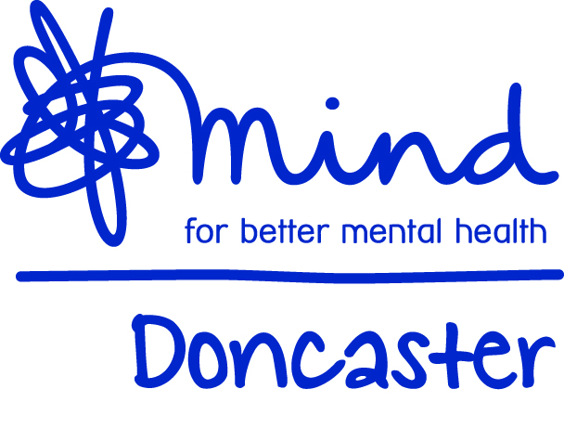

Volunteer Role Description – Mentor
The project provides adults who are struggling with their mental health the opportunity to enhance their recovery by working one to one alongside a mentor to identify meaningful goals and work towards these to enable a more fulfilling life.
The primary aim of this role is to support a client to set personal, recovery focussed goals and work independently towards small actions. To increase resilience, independence and equip clients with increased coping strategies.
Role Title: Mentor
Commitment: Up to 2 hours a week for, ideally a minimum commitment of 12 weeks is requested in order to provide consistency for clients. The day and time of the meeting is negotiable and sessions can take place at Doncaster Mind or in a community setting.
Tasks:
- To conduct initial introduction sessions with the client using a recovery tool to enable the client to consider and set development plans and objectives.
- To review progress of goals and support the client to review their progress
- To write a summary of case notes following each session
- To develop knowledge of appropriate services, activities and opportunities in order to better support the client.
Essential skills:
- Empathy and the ability to relate to difficulties a client may be experiencing with their mental health
- Knowledge of the barriers that people may face when recovering from mental health difficulties
- Excellent verbal and written communication skills
- The ability to work as part of a team
- Organisational and time management skills
- Good ICT proficiency
Desirable skills:
- Experience of supporting people recovering from mental ill health
- Professional qualification and/or experience in mentoring.
Training:
Full mentoring training will be provided
Additional training will be provided when relevant
Boundaries of the role:
To work within the organisation’s confidentiality policy and volunteer agreement.

